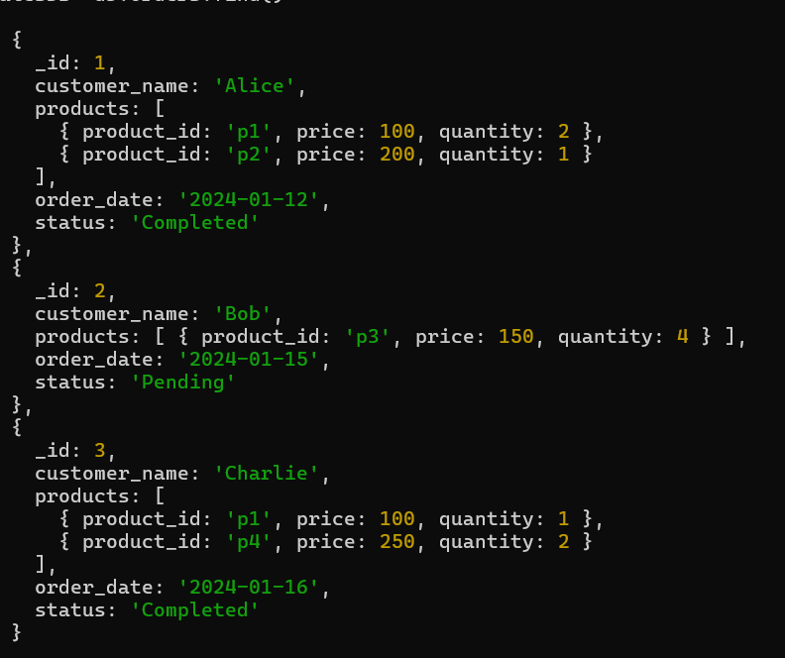

1. Calculate Total Sales for Each Order.

db.orders.aggregate([{$unwind:"$products"},{$group:{_id:"$_id",customer_name:{$first:"$customer_name"},Total_Sales:{$sum:{$multiply:["$products.price","$products.quantity"]}}}}])

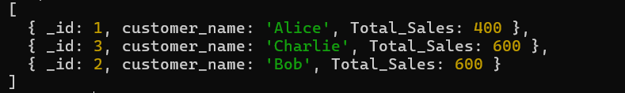

1. Calculate Average Order Value for Completed Orders.

db.orders.aggregate([{$match:{status:"Completed"}},{$unwind:"$products"},{$group:{_id:"$_id",Total_order:{$sum:{$multiply:["$products.price","$products.quantity"]}}}},{$group:{_id:null,average_order:{$avg:"$Total_order"}}}])



1. Find the Maximum Quantity Sold per Product.

db.orders.aggregate([{$unwind:"$products"},{$group:{_id:"$products.product_id",Max_quantity:{$max:"$products.quantity"}}}])

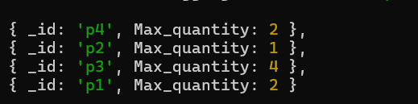

1. Find Total Number of Orders for Each Status.

db.orders.aggregate([{$group:{_id:"$status",Total_orders:{$sum:1}}}])  
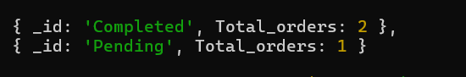

1. Calculate Total Quantity of Products Sold Across All Orders.

db.orders.aggregate([{$unwind:"$products"},{$group:{_id:"$products",Total_quantity:{$sum:"$products.quantity"}}}])

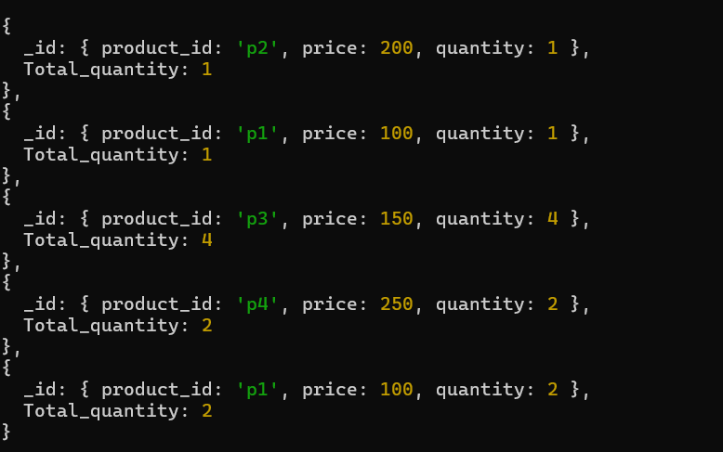

1. Get Minimum and Maximum Order Dates.

db.sales.aggregate([{$unwind:"$products"},{$group:{_id:"$products.product_id"}},{$group:{_id:"products",Distinct_products:{$sum:1}}}])

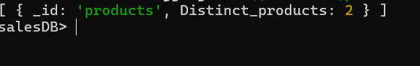

1. Find Total Sales for Each Customer.

db.orders.aggregate([ { $unwind: "$products" }, { $group: { _id: "$customerId", totalSales: { $sum: { $multiply: ["$products.price", "$products.quantity"] } } } }, { $sort: { totalSales: -1 } }] )

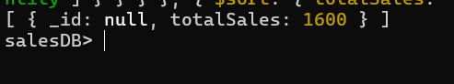

1. Calculate the Total Number of Distinct Products Sold.

db.orders.aggregate([{$unwind: "$products"},{$group: {_id: null,distinctProducts: { $addToSet: "$products.productId" }}},{$project: {totalDistinctProducts: { $size: "$distinctProducts" }}}])

